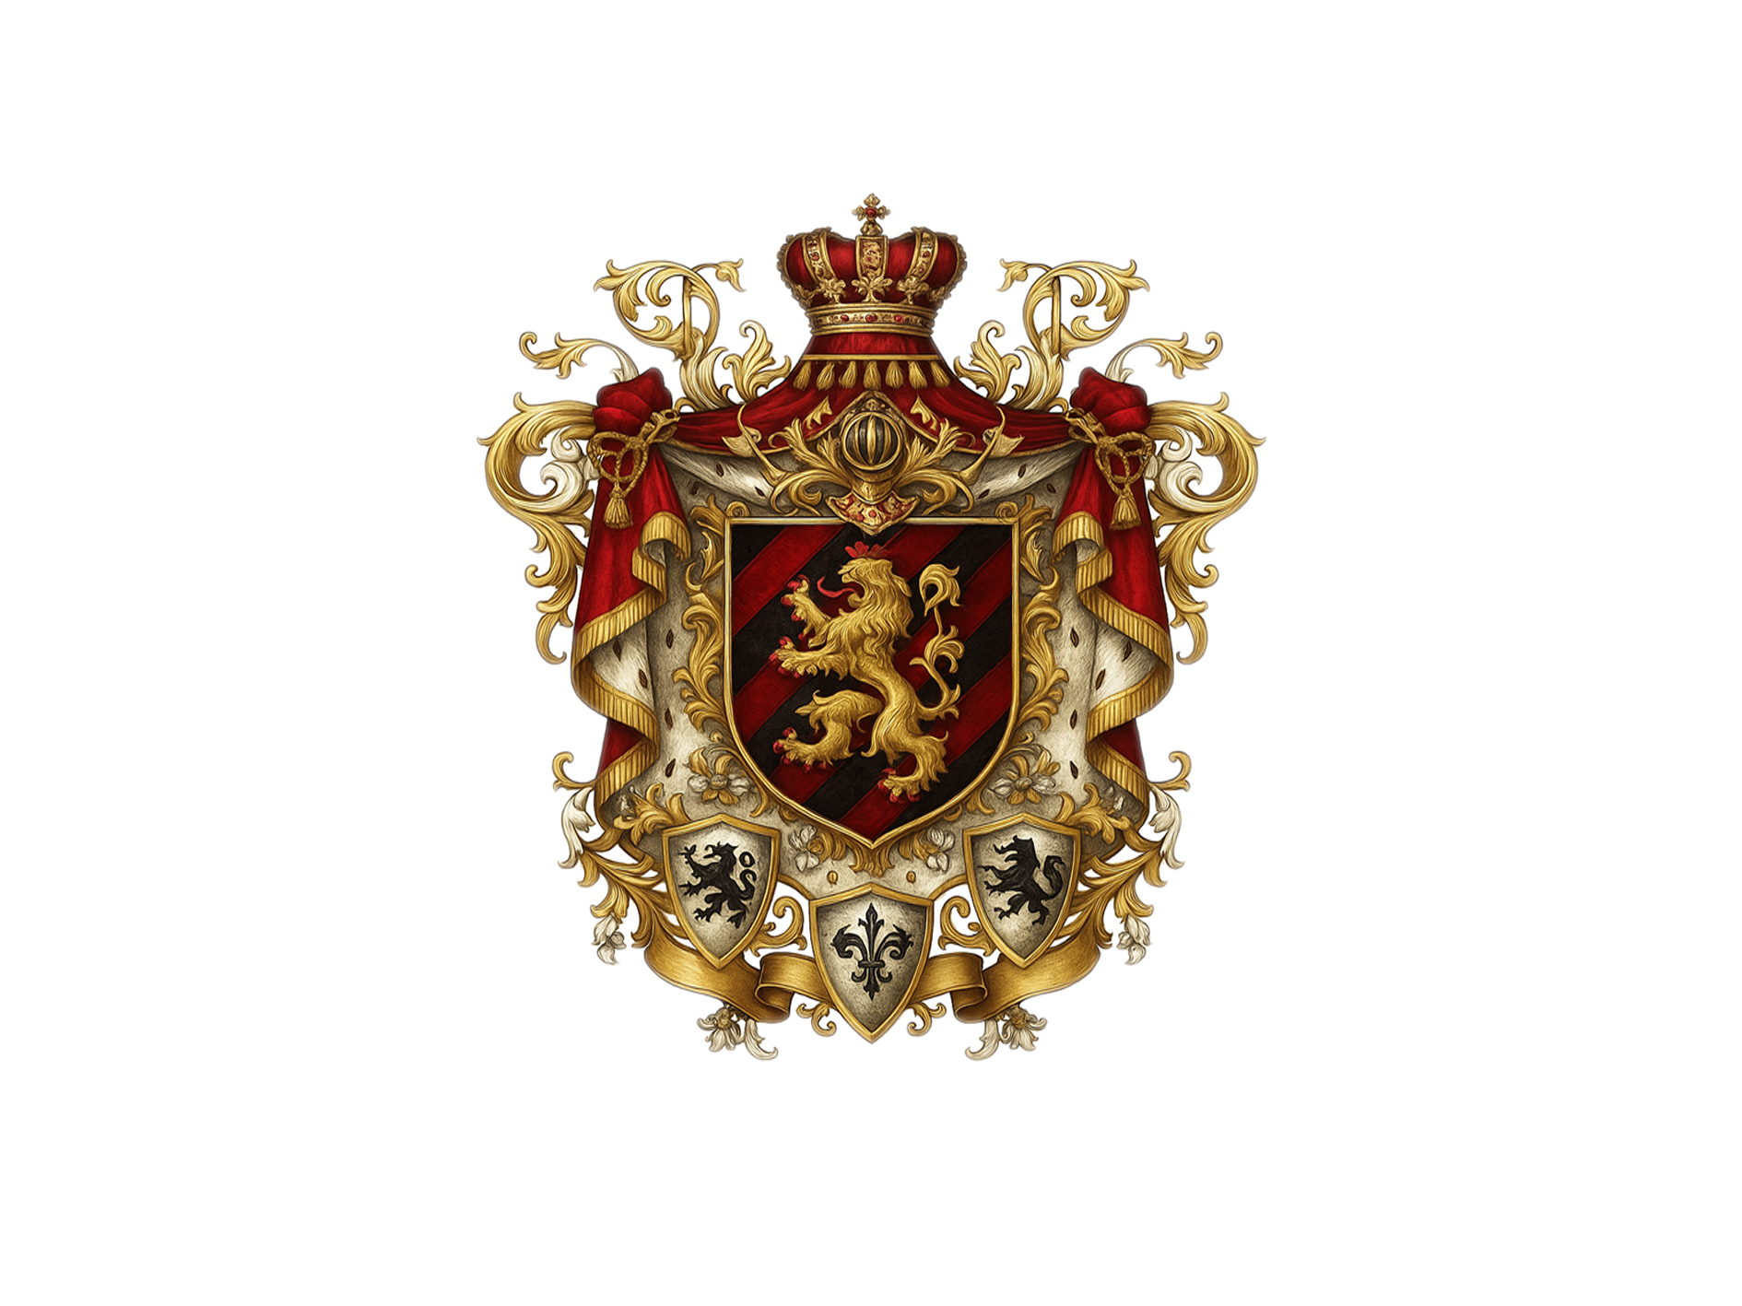
FOUNDATIONAL ROYAL CHARTER
THE CREATION AND ESTABLISHMENT OF THE MONARCHY OF SYNO AURELIUS

I. DECLARATION OF ESTABLISHMENT
By this Foundational Royal Charter, the Constitutional Monarchy of Syno Aurelius is established with immediate effect, in accordance with the will of its Creator and Founder, and by virtue of its chosen Political System: a Constitutional Monarchy governed by a Monarch as the Ceremonial and Symbolic Head of State.

II. THE MONARCHY AND THE MONARCH

Article 1: The Necessity of a Monarch
A Constitutional Monarchy, by its very nature and definition, necessitates the existence and appointment of a Monarch to serve as the sovereign and symbolic embodiment of the State. The Monarch shall stand as the custodian of its founding values, traditions, and constitutional authority.

Article 2: Founding and Identity of the Monarch
The Constitutional Monarchy of Syno Aurelius is created and established by the Monarch, Karolys Ignatius Von Lotharinge, who serves as its Creator, Founder, and Sovereign Monarch.
The Monarch, in full capacity and rights, assumes the Official Title:
His Imperial Majesty, The Imperator Grandė Dominus, Emperor Karolys Ignatius Von Lotharinge, Sovereign Monarch of Syno Aurelius, Custodian of the Dynastic Royal House of Lotharinge, Imperator Ordinis and POraetor Dominus of the Holy Order of Paladin Knights.

III. DYNASTIC IDENTITY AND HERITAGE

Article 3: The House of Lotharinge
The Monarch hereby re-establishes the Dynastic Royal House of Lotharinge, deriving its name from the historical lineage of Lothar I and Lothar II, heirs of the Emperor Charlemagne. The name "Lotharinge" reflects both a cultural and spiritual continuation of the original Carolingian legacy, while distinctly declaring a new, sovereign line unbound by fragmented claims of bloodline succession based on the creation of Syno Aurelius as Founder and appointment as the Monarch of the Constitutional Monarchy. Syno Aurelius.

Article 4: Language and Lineage
Due to the dissolution of the Carolingian Empire after the death of Charlemagne, no direct bloodline can claim uninterrupted dominion. However, the Old Frankish and Latin-derived naming conventions — such as the use of “ing,” “inge,” “ingen” or the prepositional identifiers “from” / “Von” — signify ancestral origins, geographical roots, or allegiance to legacy.
In this context, “Von Lotharinge” designates the Monarch as having emerged from the legacy of the descendants of Charlemagne, Lothar 1 and Lothar 11 and the subsequent denotations to the names of Lothar with historic proof of use of Lotharingia, Lotharingen, Lotharinge, Lorraine.
The descendants married to other Royal dynasties such as the House of Hapsburg (Austria, Belgium, Alsace) and the House of Lombard (Italy).
The Royal Title as Emperor is bestowed on the Monarch of Syno Aurelius for the creation, founding and establishment of a Country with a political format of a Monarchy.
The Monarch chooses the Country to be known and operate according to a Constitution, therefore the Country will be a Constitutional Monarchy.
Through the establishment of a Country, the Lotharinge line is reinstated with sovereign cultural succession and dynastic restoration.

IV. MONARCH’S ACT

Article 5: The Monarch’s Rights and Responsibilities
A Monarch’s Act shall henceforth be established as a binding royal document codifying the responsibilities and entitlements of the Monarch. These include:
- To be the Official Seal Bearer of the Country;
- To be the Official Title Holder of the Country;
- To act as Custodian of the Constitution and uphold the Constitutional Monarchy.
- To structure and organize the Nation-State of Syno Aurelius.
- To appoint leadership in the formation of governance.
- To ensure the preservation of peace, neutrality, and sovereignty of the Realm.
- To maintain the Cultural, Royal, and Digital Heritage of the House of Lotharinge.
- To determine the readiness and operational status of Syno Aurelius for full governmental function.
- To serve as Final Arbiter in ceremonial matters and transitional oversight with executive powers and veto right on all matters.

V. STRUCTURING THE STATE

Article 6: Formation of Governmental Leadership
The Monarch hereby appoints the primary leadership of the State of Syno Aurelius, tasked with operational governance under the principles of the Constitution:
- State President : Executive Head of State during full operational period.
- Deputy President : Legislative Head and Chief Deputy and Assistant to the President.
- Judge President : Judicial Head of the Justice Portfolio;
- The Administrator of Foreign Affairs, International Relations, Diplomacy and Representation: The Secretary of State;
- The Administrator of State Affairs and Constitutional Oversights : The Lord Chancellor, Chancellor of State
- The Head of Administrative Affairs: The Administrator-General;
- The Recorder of Official Documentation and Keeper of Records: The Chief Registrar;
- The head of Oversight: The Chief Inspector;
These leaders shall serve in office upon formal Assent of the Monarch and assume full operational capacity at the declared time of readiness.

VI. ADVISORY FRAMEWORK

Article 7: Senior Executive Advisory Committee
The Monarch shall establish a Senior Executive Advisory Committee, composed of trusted and eminent individuals to advise both the Monarch and the State President. This Committee shall:
- Provide strategic insight for national development.
- Offer constitutional, diplomatic, and institutional counsel.
- Act as a transitional authority during the foundational phase.

VII. OPERATIONAL TRANSFER OF EXECUTIVE AUTHORITY

Article 8: Commencement of Full Executive Powers
The Monarch shall, upon determining the readiness of Syno Aurelius — notably marked by the full functionality of fund transfers and infrastructural systems — formally declare the Nation operational.
At that moment, the State President shall assume full Executive, Legislative, and Judicial responsibilities as provided in the Constitution.The term of office of the State President officially begins from the date of this declaration.

VIII. FINAL PROVISION
This document shall be known as the Royal Charter of the Creation and Establishment of the Monarchy of Syno Aurelius and shall be preserved as a foundational constitutional instrument.
Top of Form
Bottom of Form
IN ROYAL TESTAMENT AND IMPERIAL SEAL

Signed and Sealed under the hand of His Imperial Majesty,
In the Throne Room of the Palace of Syno Aurelius,
In full view of the digital heavens and earthly chronicles.
✠

His Imperial Majesty
The Imperator Grandė Dominus
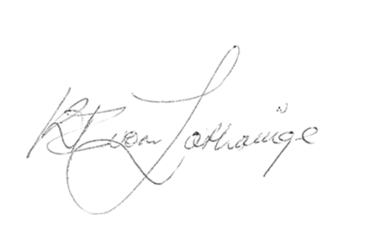
Emperor Karφlys Ignatius Von Lotharinge
Sovereign Monarch and Founder of Syno Aurelius
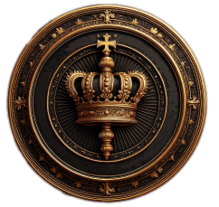
Issued on this 13th day of May, Year of 2019

