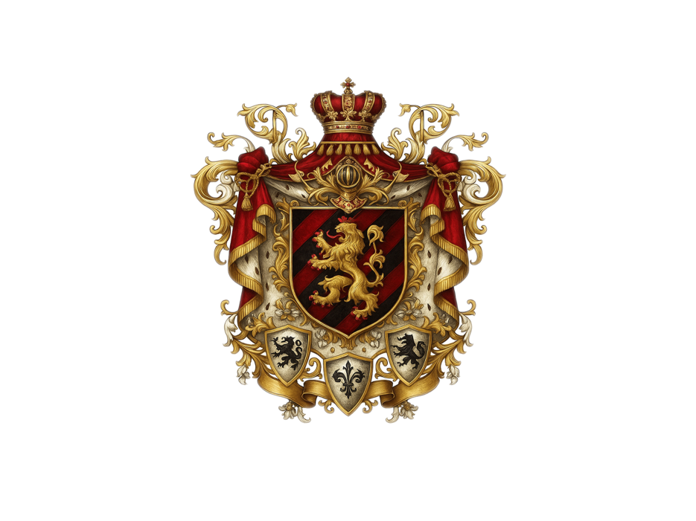

ROYAL DECREE No. I / HRD / 2025
OF THE CONSTITUTIONAL MONARCHY OF SYNO AURELIUS
BY HIS MAJESTY KAROLYS IGNATIUS FON LOTHARINGE
Monarch and Founder of Syno Aurelius

THE ROYAL DECREE ON THE HUMAN RIGHTS DECLARATION
WHEREAS Syno Aurelius is founded upon the eternal principles of justice, honor, equality, and the sanctity of life;
WHEREAS every Citizen is endowed with inviolable dignity, divine purpose, and the inalienable right to flourish in peace and freedom;
WHEREAS the Constitutional Monarchy is bound by sacred duty to uphold the Strategic Principles of Syno Aurelius for the benefit of all humankind;
NOW THEREFORE, I, Karolys Ignatius Von Lotharinge, Sovereign Monarch of the Constitutional Monarchy of Syno Aurelius, in accordance with the Constitution and by virtue of the Crown vested in me, do hereby DECLARE, PROCLAIM, AND DECREE the following as the Official Human Rights Declaration of Syno Aurelius, binding upon all Citizens, institutions, ministries, and territories within our digital and physical dominions:

ARTICLE I: UNIVERSAL EQUALITY
- All Citizens of Syno Aurelius are equal before the law and entitled to equal protection and opportunity without discrimination.
- No Citizen shall be denied their rights or dignity based on race, gender, origin, language, belief, age, ability, or digital identity.

ARTICLE II: DIGNITY AND FREEDOM
- The dignity of every human life shall be protected and honored at all times.
- No one shall be subjected to inhuman treatment, exploitation, or unjust punishment.

ARTICLE III: GENDER EQUALITY AND FAIR REMUNERATION
- All genders shall have full and equal rights in all spheres of life, including leadership, enterprise, education, and representation.
- Equal remuneration for equal work shall be an immutable law.
- Gender-based violence and inequality are crimes against the Crown and shall be prosecuted accordingly.

ARTICLE IV: SOCIAL AND ECONOMIC RIGHTS
- Every Citizen shall have access to health care, education, employment, housing, and food security.
- Education shall be free and universal; innovation shall be rewarded and supported by the State.
- Economic opportunity shall be open to all, regardless of background or status.

ARTICLE V: PRIVACY AND DIGITAL INTEGRITY
- Every individual is entitled to privacy in all physical and digital domains.
- The State shall ensure the protection of personal data, communication, and digital presence.

ARTICLE VI: FAITH, EXPRESSION, AND PARTICIPATION
- Freedom of thought, conscience, religion, and belief shall be preserved and respected.
- Citizens may express themselves freely and participate in governance and the Digital Parliament without fear of suppression.

ARTICLE VII: RIGHTS OF VULNERABLE GROUPS
- Children, elders, persons with disabilities, and the marginalized shall receive special care, protection, and priority support.
- No group shall be left behind in the progress of the Nation.

ARTICLE VIII: JUSTICE AND REMEDY
- Every Citizen has the right to legal recourse, protection, and due process under law.
- Justice shall be swift, impartial, restorative, and accessible to all.

ARTICLE IX: ENFORCEMENT AND PROMULGATION
- This Human Rights Declaration shall be incorporated into all national frameworks, laws, policies, and international agreements of Syno Aurelius.
- It shall be taught in all educational institutions, upheld in every public office, and displayed in all diplomatic missions.
- Violation of this Declaration shall constitute a breach of Royal Trust and be subject to national legal remedy.

GIVEN UNDER OUR HAND and affixed with the Royal Seal of Syno Aurelius, on this Twenty-Third Day of April in the Year Two Thousand and Twenty-Five.
BY ORDER OF THE CROWN
Karolys Ignatius Von Lotharinge
Monarch of Syno Aurelius
Guardian of the Digital Realm
Protector of the Citizens
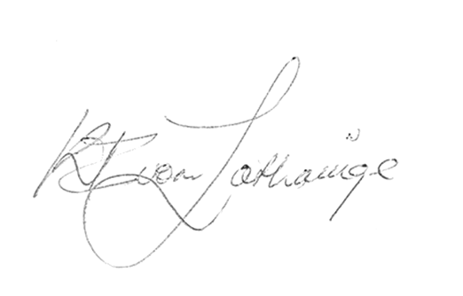



Top of Form

Bottom of Form

