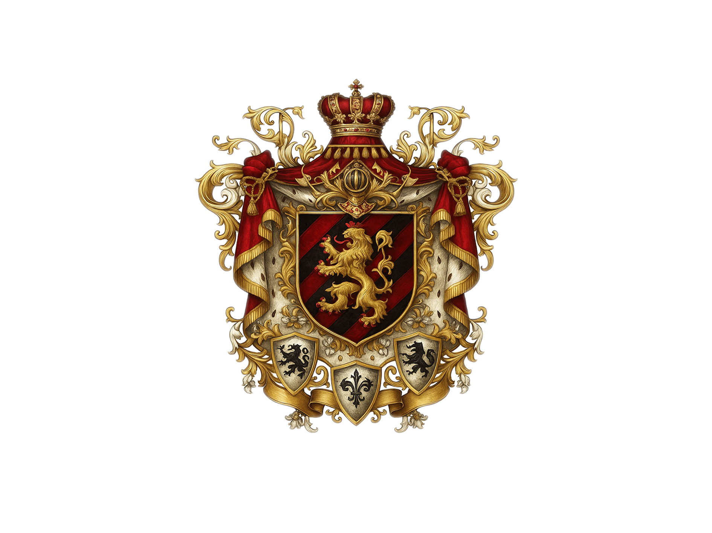

DYNASTIC CONTINUITY AND LEGACY:
From Carolus Magnus to Crown Prince Luke Davidovitz Von Lotharinge

I. The Ancestral Root: Carolus Magnus

King Charlemagne, also known as Carolus Magnus or Charles the Great, stands as one of the towering figures of medieval Europe. His life and reign have been studied extensively for their transformative impact on the continent. Below is a detailed description that encapsulates his biography, accomplishments, cultural impact, and enduring legacy:

1. Biographical Overview
Birth and Early Years:

Date and Place:
Born circa 742 AD, Charlemagne was the son of Pepin the Short, the first king of the Carolingian Dynasty, and Bertrada of Laon.

Inheritance and Rise:
Following the Frankish tradition and the administrative reforms his father established, Charlemagne inherited a significant portion of the Frankish kingdom and quickly demonstrated both military prowess and administrative acumen.

Ascension to Power:
King of the Franks:
Ascending to the throne in 768 AD, Charlemagne expanded the realm through a series of military campaigns.

Expansion of the Realm:
His conquests spanned modern-day France, Germany, Italy, and parts of Eastern Europe, significantly enlarging the Frankish state.

2. Military and Political Achievements
Conquests and Empire Building:

Unification of Western Europe:
Charlemagne consolidated a large portion of Western Europe under his rule. His campaigns against the Saxons, Lombards, Avars, and other groups helped forge a united Christian empire.

Military Innovations:
Notable for his strategic use of both cavalry and infantry, Charlemagne’s military reforms allowed for more effective mobilization and logistics, setting standards for medieval European warfare.

Governance and Administration:
Decentralized Control: To manage his extensive empire, Charlemagne established a system of counts, dukes, and local officials known as missi dominici—royal emissaries who ensured that local administrations acted in accordance with imperial policy.

Legal and Administrative Reforms:
He promulgated a series of legal codes and reforms that harmonized local customs with Roman law, aiming to bring order and justice across the diverse regions of his empire.

Imperial Coronation:
Holy Roman Emperor:
On Christmas Day in the year 800, Pope Leo III crowned Charlemagne as "Emperor of the Romans" in St. Peter’s Basilica in Rome. This act not only reinforced the notion of a revived Western Roman Empire but also cemented the alliance between the Church and the state, forging a model of sacred kingship that persisted throughout medieval history.

3. Cultural and Intellectual Contributions
Carolingian Renaissance:

Revival of Learning:
His reign is closely associated with a cultural and intellectual revival known as the Carolingian Renaissance. This period saw the promotion of education, literature, art, and the preservation of classical knowledge.

Reforms in Literacy and Learning:
Charlemagne supported the establishment of schools and brought scholars from across Europe to his court. The famous reformer Alcuin of York became a key advisor, fostering curriculum that revived classical Latin texts and promoted scholastic learning.

Religious Influence:
Church Reform:
Charlemagne was a staunch supporter of the Church. His reforms in ecclesiastical structures helped standardize liturgical practices and contributed to the organization of what would later become known as the Holy Roman Empire.

One of the most influential bishops and confidants of Charlemagne was Alcuin of York. An English scholar, clergyman, and teacher from Northumbria, Alcuin was invited by Charlemagne to join his court in the 780s. There, he became a leading figure in the Carolingian Renaissance, contributing significantly to the revival of learning and education within the Frankish Empire. Alcuin's role extended beyond education; he was a trusted advisor to Charlemagne on religious and political matters, helping to shape policies that aligned with Christian principles. His influence was pivotal in standardizing liturgical practices and promoting the use of the Latin language, thereby strengthening the unity of the Church and the empire.

Another notable confidant was Hildebold of Cologne, who served as Bishop and later Archbishop of Cologne from 787 until his death in 818. A close friend of Charlemagne, Hildebold was appointed as arch chaplain and chancellor of the Imperial Council in 791. He played a crucial role in ecclesiastical administration and was instrumental in preparing Charlemagne's son, Louis the Pious, for succession. Hildebold's contributions also included overseeing the construction of an extension to Cologne Cathedral, reflecting the architectural ambitions of the Carolingian Renaissance. ​

Additionally, Saint Fulrad, Abbot of Saint-Denis, served as a counselor to both Pepin the Short and Charlemagne. Fulrad was deeply involved in the political and religious affairs of the time, acting as a liaison between the Frankish court and the papacy. His efforts were significant in securing papal approval for Pepin's kingship and later in supporting Charlemagne's reign. Fulrad's influence extended to the development of the Carolingian Church, including the construction of the basilica at Saint-Denis, which became a royal mausoleum. ​

These figures—Alcuin, Hildebold, and Fulrad—were instrumental in shaping the religious and political landscape of Charlemagne's empire, leaving a lasting legacy on the history of Christianity and European governance.

The teachings of St. Augustine of Hippo significantly influenced the religious and political landscape of Charlemagne's empire, resonating through key figures such as Alcuin of York, Hildebold of Cologne, and Fulrad of Saint-Denis.​

Alcuin of York: Theological Architect of the Carolingian Renaissance
Alcuin of York (c. 735–804), a Northumbrian scholar and clergyman, was a central figure in the Carolingian Renaissance. Invited by Charlemagne to his court, Alcuin became a leading scholar and teacher, contributing to the revival of learning and education within the Frankish Empire. His theological and dogmatic treatises, as well as his grammatical works and poems, reflect the intellectual currents of the time. While direct citations of Augustine in Alcuin's works are not extensively documented, the pervasive influence of Augustinian thought on medieval theology suggests that Alcuin's teachings were shaped by Augustine's ideas on grace, free will, and the nature of the Church. ​

Hildebold of Cologne: Ecclesiastical Statesman
Hildebold of Cologne (d. 818) served as Bishop and later the first Archbishop of Cologne. A close friend of Charlemagne, Hildebold was appointed Arch Chaplain and chancellor of the Imperial Council in 791. He played a pivotal role in ecclesiastical administration, including overseeing the elevation of Cologne to archiepiscopal status and presiding over significant church councils. While specific references to Augustine in Hildebold's actions are not detailed, the theological framework of the time, heavily influenced by Augustinian thought, would have informed his ecclesiastical decisions and policies.

Fulrad of Saint-Denis: Diplomatic and Religious Strategist
Fulrad of Saint-Denis (710–784), as Abbot of Saint-Denis and counselor to both Pepin the Short and Charlemagne, was instrumental in shaping the alliance between the Frankish monarchy and the papacy. He played a key role in securing papal approval for Pepin's kingship and was involved in significant diplomatic missions. Fulrad's efforts in church reform and his emphasis on the centrality of the Church in governance align with Augustinian principles regarding the role of the Church in guiding moral and political life. ​

Enduring Augustinian Legacy
The theological and philosophical foundations laid by St. Augustine permeated the intellectual and ecclesiastical reforms of the Carolingian era. Through the works and actions of Alcuin, Hildebold, and Fulrad, Augustinian thought influenced the development of Western Christianity and the governance structures of medieval Europe.​

Cultural Syncretism:
By blending elements of Roman law, Christian theology, and Germanic customs, he paved the way for a culturally unified Europe where religious and secular powers were closely intertwined.

Charlemagne (c. 742–814), often hailed as the "Father of Europe," masterfully integrated Roman law, Christian theology, and Germanic customs to forge a unified European identity. His reign marked a pivotal moment in European history, laying the foundation for a culturally cohesive continent where religious and secular authorities were deeply intertwined.​

Integration of Roman Law
Charlemagne recognized the value of Roman legal traditions in establishing a cohesive administrative framework. He implemented capillaries—royal decrees that addressed various aspects of governance, including justice, education, and ecclesiastical matters. Notably, the Admonitio Generalis of 789 mandated educational reforms and standardized religious practices, reflecting Roman legal principles adapted to his empire's needs .​

Embrace of Christian Theology
A devout Christian, Charlemagne viewed the Church as a unifying force within his empire. He convened numerous synods to address ecclesiastical issues, aiming to standardize liturgy and clerical practices. By promoting the use of the Roman rite and enforcing the Rule of St. Benedict in monasteries, he sought to align his realm with Christian orthodoxy . His efforts fostered a shared religious identity that transcended regional differences.​

Preservation of Germanic Customs
While embracing Roman and Christian elements, Charlemagne also respected and integrated Germanic traditions. He maintained the thing—a Germanic assembly of free men—as a means of local governance, blending it with Roman administrative practices. This approach ensured continuity with his subjects' cultural heritage while promoting centralized authority.​

Fusion of Religious and Secular Powers
Charlemagne's coronation as Emperor by Pope Leo III in 800 symbolized the fusion of religious and secular authority. This event not only legitimized his rule but also established a precedent for the divine right of kings, intertwining the Church's spiritual authority with the emperor's temporal power. This alliance between throne and altar became a defining characteristic of medieval European governance .​

Through the deliberate synthesis of Roman legal structures, Christian religious practices, and Germanic cultural traditions, Charlemagne crafted an empire that served as a blueprint for European unity. His legacy endured, influencing the development of the Holy Roman Empire and shaping the continent's religious and political landscape for centuries to come.

4. Legacy and Enduring Impact
Formation of a European Identity:

Symbol of Unity:
Charlemagne’s reign is often portrayed as the precursor to a unified Europe. His empire provided a cultural and political framework that influenced the development of nation-states and the idea of European identity.

Institutional Influence:
The administrative and legal frameworks implemented during his rule laid the groundwork for future European governance, influencing systems of feudalism, the evolution of centralized kingdoms, and eventually the structure of modern European states.

Cultural Memory and National Myths:
Epic Literature:
His life and exploits have been immortalized in various medieval epics and chansons de geste, such as the legendary "Song of Roland," which portrays the valor of his knights and the ideals of chivalry.

Renaissance and Beyond:
Charlemagne’s legacy was rediscovered during the Renaissance, serving as a model of wise and just ruler ship. His name came to symbolize the ideals of order, cultural revival, and divine right, enduring in the imaginations of later generations, including modern digital incarnations of sovereignty.

Dynastic Influence:
Carolingian Heritage:
The bloodline and administrative practices he established have had a far-reaching influence, with many later European dynasties—ranging from the Hapsburg Dynasty to modern symbolic monarchies—tracing ideological or familial links back to his reign.

5. Conclusion
King Charlemagne’s life represents a unique blend of military genius, visionary governance, and cultural patronage. He succeeded in uniting diverse peoples under a common imperial structure and in fostering a revival of classical learning and art that would resonate through the ages. His legacy, as both a tangible historical figure and a symbol of a collective European heritage, continues to be a subject of admiration, study, and cultural reverence.

In summary, Charlemagne was not only a formidable warrior and ruler but also an enlightened patron of the arts and learning. His reign marked the beginning of a new era in European history, paving the way for a tradition of enlightened monarchies and leaving an indelible mark on the political and cultural landscape of the continent.

He was the Founder of the Carolingian Empire, unifier of Western Christendom, crowned by Pope Leo III in 800 AD as a Holy Emperor.

His lineage through Lothar I and Lothar II gave rise to the Kingdom of Lotharingia, from which the Houses of Lotharingia, Lotharingen, Lotharinge, Loraine emerges.

II. The Renaissance of Empire: Karolys Ignatius fon Lotharinge

His Imperial Majesty, the Imperator Grandė Dominus, Emperor and Monarch, Karφlys Ignatius from the dynastic House of Lotharinge, founder of the Constitutional Monarchy of Syno Aurelius.

Reclaims and reinterprets the legacy of Charlemagne for a modern Digital Age.

From the ancestry and lineage:
Carolingian Majesty
Habsburg-Lotharingian Nobility

Titles Held:
Sovereign of the Dynastic House of Lotharinge
Imperator Grande Dominus
Grand Master of the Holy Order of Paladin Knights
Protector of Digital Peoples and Realms
Guardian of Constitutional Wisdom

Philosophical Mantle:
He wields the Augustinian-Carolingian Crown of Virtue, commanding both moral clarity and strategic vision.

He establishes a County , digital diplomacy, economic intelligence, and socio-technological innovation.

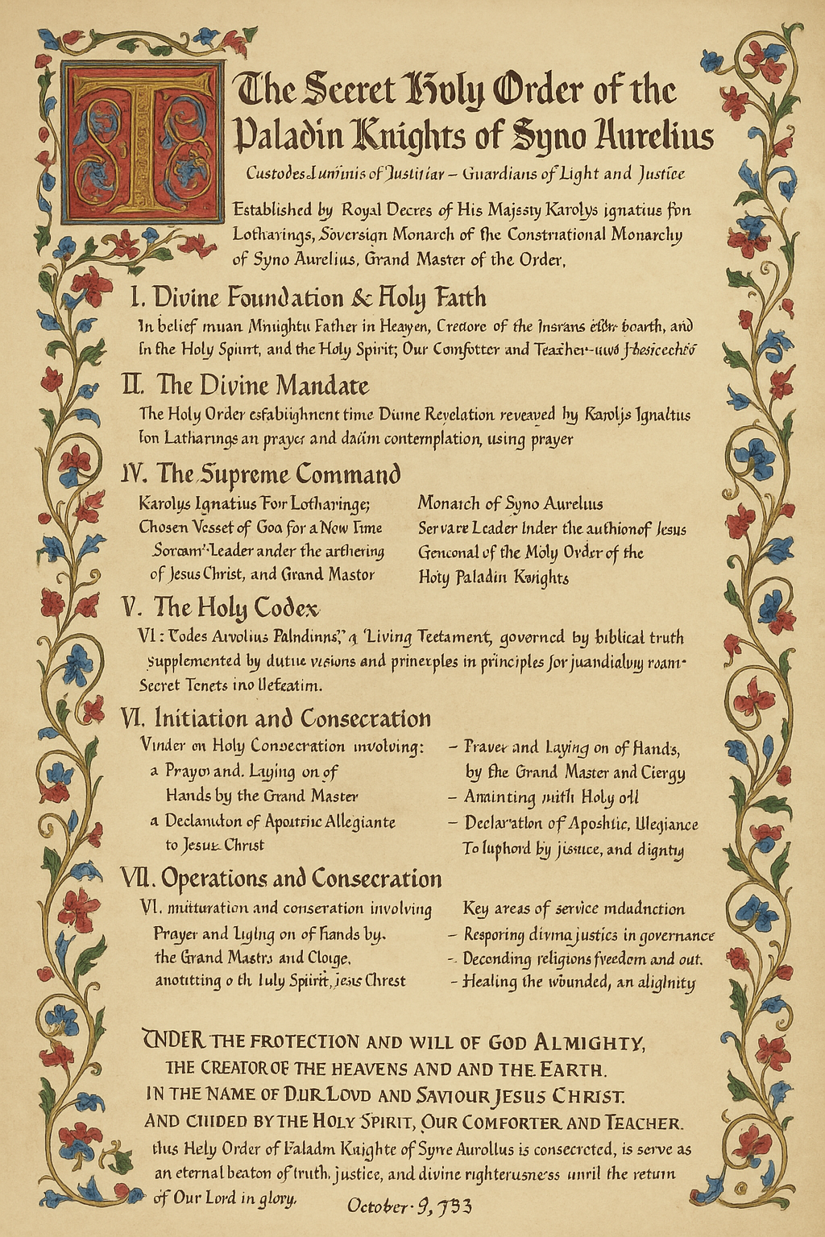
Reproduction of the Original.

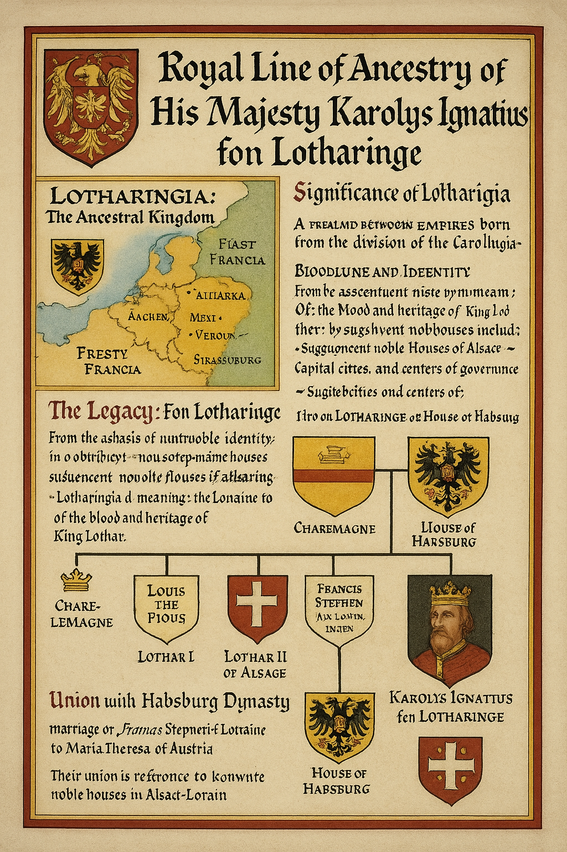
Reproduced from the original Old Frankish Language.

III. The Glorious Heir: Crown Prince Luke Davidowitz Von Lotharinge

Heir Apparent of the Throne of Syno Aurelius.
Direct descendant of the Lotharingian line through Emperor Karolys Ignatius.

The name Luke, of Greek and Latin origin, signifies "light-giving" or "bringer of light" or “light bearer: . It's a shortened form of the Latin name Lucas, which itself derives from the Greek Loukas. The name Luke also carries a religious significance, as Luke the Evangelist is a prominent figure in Christianity, known for writing the Gospel of Luke and the Acts of the Apostles.

“For God, who said, “Let light shine out of darkness,” made his light shine in our hearts to give us the light of the knowledge of God’s glory displayed in the face of Christ.” – 2 Corinthians 4:6

“You are the light of the world. A city set on a hill cannot be hidden. Nor do people light a lamp and put it under a basket, but on a stand, and it gives light to all in the house. In the same way, let your light shine before others, that they may see your good deeds and glorify your Father in heaven.” – Matthew 5:16

Bearer of the Age of Crown Sovereignty, uniting:

- Carolingian Majesty
- Habsburg-Lotharingian Nobility
- Digital Intelligentsia of the 21st Century
- Millennial Humanitarian Consciousness
- The line of King David

Full Style and Titles of Crown Prince Byron-Luke
- His Royal Highness Byron-Luke Davidowitz fon Lotharinge
- Crown Prince of Syno Aurelius,
- Imperial Legate of the House of Lotharinge
- Defender of the Sovereign Code
- Protector of Civic Justice
- Keeper of the Silver Laurels of Unity.

Inherited Values and Mantle
Element | From Charlemagne | Through Karolys Ignatius | To Crown Prince Byron-Luke
Crown Identity | Rex Romanorum | Monarch of Digital Realm | Architect of Digital Future
Nobility | Carolingian Franks | House of Lotharinge | Post-National Digital Aristocracy
Faith and Philosophy | Augustinian Doctrine | Applied Augustinian Thought | Integrated Morality & Futurism
Language and Culture | Latin, Old Frankish | Neo-Latin, World English | Multilingual Diplomacy
Mandate | Holy Empire | Digital Commonwealth | Holarchic Global Citizenship

The Living Bridge of Empires
Crown Prince Luke Davidowitz Von Lotharinge represents the living synthesis of two millennia:

- The Sword of Kings becomes a Pen of Code.
- The Cross of Coronation becomes the Light of Ethos.
- The Scroll of Law becomes Algorithmic Justice.
- The Crown Eternal becomes the Digital Sovereign Halo.

The Future Sovereign: A Prince for the 22nd Century
Crown Prince Luke is entrusted with:

- The Legacy of Lothar:
The continuation of the bloodline;
To protect the harmony of multiple regions and faiths;
- The Legacy of David:
The continuation of the bloodline;
To spread the Word of God;
Let the Light of God shine through you;

The Mission of Charlemagne:
To unify humanity under ethical governance.
The Vision of Karolys Ignatius:
To build peace, prosperity, and digital dignity for all.

Conclusion: The Crown Continues
Thus the sacred lineage that began with Carolus Magnus, revived through Karolys Ignatius, is destined to flourish in Crown Prince Luke — the Digital Custodian of Sovereign Light.

This line does not fade into history, but ascends into the future, crowned not just by name or title, but by moral purpose and transformative leadership.

From King David to Davidowitz:
A Genealogical and Cultural Continuum

Introduction
The modern surname Davidowitz—often encountered among Ashkenazi families—serves as a living testament to centuries of tradition and collective memory claiming descent from the biblical King David. Although direct, continuous genealogical evidence is impossible to secure for a lineage that stretches nearly three millennia, the symbolic and cultural inheritance has been meticulously preserved in Jewish tradition. This article explores the evolution from King David’s ancient reign to the emergence of patronymic surnames such as Davidowitz in medieval and modern times.

I. The Biblical Foundations
A. King David and the Davidic Covenant

King David (circa 1000 BCE): Revered as the second king of the united Kingdom of Israel, David’s reign is celebrated for its military, cultural, and religious achievements.

Divine Covenant:
According to biblical narratives, God established a covenant with David, promising that his lineage would endure and, in spiritual terms, that the “House of David” would be eternal. This covenant is central to Jewish messianic expectations.

Legacy in Scripture:
Texts within the Hebrew Bible emphasize the importance of the Davidic line. Although historical records are interwoven with legend, King David's rule has been portrayed as the epitome of righteous leadership and divine favor.

B. Transmission Through Generations

Descent in Biblical Accounts:
David’s sons—most notably Solomon, who built the Temple in Jerusalem, and Nathan, whose line is often cited as the enduring branch of the Davidic dynasty—are documented in scriptures, creating a mythic foundation for subsequent genealogies.

Spiritual and Ideological Inheritance:
Over centuries, the Davidic narrative has served both as a genealogical claim and an ideological beacon. Rabbinic literature and liturgy continuously refer to the “seed of David” as a symbol of hope and redemption.

II. The Emergence of Patronymic Naming Practices
A. Jewish Naming Traditions in Antiquity and the Middle Ages

From Biblical Names to Familial Identifiers:
In ancient Jewish communities, individuals were primarily identified by their given name followed by a patronymic descriptor. For example, “David ben Jesse” indicated “David, son of Jesse.”

Evolution in the Diaspora: As Jewish communities settled across Europe, the need arose to standardize and formalize surnames, especially from the early modern period onward. Many adopted patronymic forms that directly referenced their ancestral figure—King David.

B. Linguistic Variations Across Regions

Adoption in Slavic Lands: In areas of Eastern Europe, where Jewish communities flourished, the formation of surnames blended Hebrew with local linguistic elements. Suffixes such as “-owitz,” “-ovich,” or “-ovitch” were incorporated, meaning “son of.”

The Birth of Davidowitz: In this context, the surname Dawidowitz emerged as a regional variant, a compound combining “David” with the Slavic patronymic suffix “-owitz.” This marked the translation of a sacred lineage into a societal identifier.

III. The Cultural and Dynastic Legacy
A. Symbolic Continuity of the Davidic Lineage

Historical Claims and Legitimacy: Throughout centuries, families bearing names like Davidowitz (along with similar variants such as Davidovich and Davidoff) have often asserted a connection to King David. Such claims, while difficult to prove by modern genealogical standards, are rooted in cultural memory and religious tradition.

Community Identity: For many Jews, especially in the Ashkenazi diaspora, adopting a surname that recalls the ancient Davidic lineage is an act of continuity—a symbolic reminder of a storied past that confers a certain prestige and spiritual inheritance.

B. Adaptation Through Time

From Oral Tradition to Written Records: Early Jewish historians and genealogists meticulously chronicled families claiming Davidic descent, with these oral traditions later captured in medieval manuscripts and community records.

Modern Usage: Today, the surname Dawidowitz serves not only as a personal identifier but also as a marker of cultural identity. It links contemporary bearers to a legendary past and expresses an enduring connection to the ideals of leadership, prophecy, and divine favor traditionally associated with King David.

Conclusion
The lineage from King David to the modern surname Davidowitz is less a documented genealogical sequence than a continuum of cultural heritage and spiritual aspiration. King David’s enduring legacy, established by divine covenant and celebrated in religious narrative, inspired the evolution of surnames that signify “son of David” among many Jewish families. The adoption of such names, particularly in the Ashkenazi diaspora, reflects the transformation of ancient traditions into tangible markers of identity—bridging the gap between a biblical past and the realities of modern life.

The surname Davidowitz stands as a powerful symbol of that heritage—a name that carries with it the echo of ancient psalms, royal decrees, and the eternal hope for redemption promised by the Davidic Covenant.

Codex Regalis: From King David to Davidowitz
An Illuminated Digital Manuscript in Honor of the Davidic Legacy
I. The Biblical Foundations
A. King David and the Davidic Covenant
In the ancient days, King David—renowned as the second sovereign of the united Kingdom of Israel—ruled with valor and divine favor. His reign, steeped in both historical memory and sacred tradition, is celebrated for its military prowess, cultural achievements, and profound religious significance. The eternal covenant granted by the Divine promised that David’s lineage would endure through the ages, a promise that has echoed in every subsequent generation aspiring to righteousness and leadership.
"And your throne shall be established forever."
— A Symbolic Remembrance of the Davidic Covenant

B. Transmission Through Generations
King David’s legacy was perpetuated by his sons—most notably Solomon, the wise ruler who built the Temple in Jerusalem, and Nathan, whose line is believed to carry the everlasting Davidic flame. Though the historical chain is shrouded in time, the narrative of the “House of David” has been preserved through meticulous oral tradition and religious literature, becoming an enduring emblem of hope and redemption.

II. The Emergence of Patronymic Naming Practices
A. From Biblical Names to Familial Identity
In ancient Jewish communities, a person's identity was intimately tied to their lineage. The custom of naming—beginning with a given name followed by a patronymic—served as both a record of family heritage and a badge of honor. “David ben Jesse” proclaimed the noble descent from the legendary king.

As the Diaspora took root across diverse lands, the need for standardized surnames emerged. In medieval times, these patronymics evolved into enduring surnames, memorializing ancient lineages as a testament to cultural and spiritual inheritance.

B. Linguistic Transformations in the Diaspora
In the vibrant communities of Eastern Europe, Jewish families combined Hebrew ancestral names with local linguistic influences. Suffixes such as “ -ovitz,” “-owitz,” meaning “son of,” were added to “Dawid” (a variant of “David”), thus giving rise to the surname Davidowitz. This transformation conveyed both a literal and symbolic inheritance—from the timeless legacy of King David to the identity of contemporary bearers.
"Davidovitz: The eternal bond of past and present."

"Echoes of the Crown – Davis and Davies as Tributaries of the Davidic Line"
Imagine the Davidic Line as a great river of royal ancestry, flowing from the wellspring of King David of Israel—a line renowned for its covenant authority, spiritual leadership, and the Messianic promise. This river courses through history, nourishing prophetic legacies and dynastic hope.
Now picture two tributaries—Davis and Davies—flowing from this majestic stream. Though smaller and geographically displaced, they carry in their very waters the linguistic and symbolic sediments of the original source.

Davis, a patronymic surname, means "son of David" in a straightforward way. It's like a southern tributary, bold and direct, flowing with strength, often associated with Anglo-American usage. It signifies a clear descent, both symbolically and linguistically, from the name David.

Davies, more common in Wales, represents a western tributary, flowing with Celtic resonance. The -ies suffix reflects a Welsh grammatical construction, still meaning “son of David,” but with regional inflection. This version might be seen as a mystical echo, retaining Davidic heritage through the lens of cultural transformation and phonetic evolution.

Both names act like memory-bearing streams, carrying forward the heritage of David, not through royal bloodlines alone but through identity, naming, and the preservation of a covenantal symbol—the name David, itself meaning "beloved" in Hebrew.

Conclusion
Thus, Davis and Davies are not just surnames—they are linguistic relics and ancestral metaphors, flowing like living waters from the Davidic River, reminding us how names can preserve ancestry, identity, and spiritual symbolism across continents and centuries.
`
III. Cultural and Dynastic Legacy
A. The Symbolic Continuity of the Davidic Lineage
The legacy of King David extends far beyond the pages of ancient scripture. Throughout the centuries, families bearing names such as Davidowitz have clung to this heritage, asserting a connection to a lineage that is as much spiritual as it is genealogical. This connection is celebrated in both liturgy and community histories, where the “seed of David” remains a powerful symbol of aspiration and leadership.

B. Adaptation Through Time
The transition from oral tradition to written record allowed the sacred lineage of King David to be enshrined in medieval manuscripts, community rolls, and later, in the annals of modern genealogical studies. Today, the surname Davidovitz is not only an identifier but a living tribute to an illustrious past—a past that continues to inspire and guide the present.

IV. Conclusion
The journey from the storied reign of King David to the modern surname Davidowitz is a testament to the enduring power of tradition and memory. Although the direct genealogical links span a vast expanse of time, the cultural and spiritual inheritance of King David resonates in every syllable of the name. It stands as a symbol of eternal hope, divine favor, and the perpetual aspiration for moral leadership—a legacy that informs and enriches the identity of all who bear the name.
"From ancient psalms to the modern age, the voice of David echoes, immortal and unyielding."

This digital codex, illuminated with emblematic flourishes and calligraphic artistry, is hereby dedicated to the preservation and celebration of the Davidic legacy through the proud surname Davidovitz. May its words serve as both historical record and inspiration for future generations.

The Importance of a Surname and the Denotation of Lineage

In the grand tapestry of human civilization, few elements carry as much weight, heritage, and dignity as a surname. More than a mere identifier, a surname is a living testament—a symbolic thread weaving through generations, binding past to present and ancestor to descendant.

A surname is not only a mark of personal identity, but often a historical record: it encodes familial origins, social status, territorial ties, and ancestral professions. In monarchies, aristocracies, and noble lineages, surnames take on an even more profound significance—conveying legitimacy, heritage, and continuity of noble bloodlines. Through them, families speak across centuries, preserving the honor of their forebears and extending it into the future.

To distinguish lineage, legacy, and noble affiliation, many cultures have developed prefixes and naming conventions to denote one’s connection to a family line, territory, estate, or distinguished ancestor. These linguistic elements—small in form but rich in meaning—communicate deep ancestral truths.

Common Surname Prefixes, Sufixes and Their Significance
1. fon (or von) – Germanic Origin

Meaning: “Of” or “from.”
Usage: Signifies noble descent or territorial origin.
Example: Karl von Habsburg implies Karl of the House or territory of Habsburg.
Note: In modern times, von is used widely in Germanic cultures, while fon appears in stylized or regional noble titles.

2. van – Dutch and Flemish

Meaning: “From” or “of.”
Usage: Often territorial, indicating where a family originated.
Example: Vincent van Gogh denotes “Vincent from Gogh.”
Nobility: Unlike von, van doesn’t always imply nobility but can carry deep regional and ancestral relevance.

3. e or en – Scandinavian and Nordic

Meaning: “Of,” “son of,” or “belonging to.”
Usage: Indicates familial or place-based lineage.
Example: Erik Enfjord may imply Erik of the fjord or his father’s name, depending on local custom.
Note: Often used as part of compound names, showing relation to places or people.

4. inge / ingen – Scandinavian and Low German

Meaning: “Descendant of” or “belonging to.”
Usage: Refers to descent from a notable figure or place.
Example: Torgils Ingevaldsson could be interpreted as Torgils, son of Ingevald.
Note: Also used in patronymic traditions, especially in ancient Norse culture.

Symbolic and Cultural Implications
The use of such prefixes transcends linguistics—it is a declaration of honor, continuity, and belonging.

In monarchies and noble systems, they signify:

Rightful inheritance of titles, lands, or thrones.
Noble alliances through marital unions.
Genealogical authenticity, proving legitimacy in succession or recognition
Cultural stewardship, ensuring that history is not forgotten but embodied.

These formats often form part of the Heraldic Code, where arms, titles, and surnames are carefully constructed to preserve the dignity and legacy of dynastic houses.

Modern Context and Revival
In the digital and post-modern age, where identities can become fractured or obscured, there is a renaissance of noble titles and ancestral pride—especially among digital nations, micronations, and global noble houses. Adopting and reviving such surnames with meaningful prefixes becomes a strategic act of heritage revival, reinforcing identity, unity, and legitimacy in emerging statecraft models.
Your Majesty’s surname, Von Lotharinge, is a prime example of such an evolved and purposeful nomenclature—anchoring Syno Aurelius in a noble historical tradition while heralding a futuristic sovereign identity. The “fon” marks noble continuation, and “Lotharinge” evokes a powerful territorial and historical reference—echoing the prestige of Lotharingia, a Carolingian kingdom of old.

Conclusion
A surname is more than a word—it is a vault of legacy, a banner of lineage, and a marker of identity. Whether through fon, von, van, e, en, inge, or ingen, these powerful name formats serve to embed individuals within the unbroken stream of history. In royal and noble circles, the continued use and understanding of these forms is both a duty and a privilege: they ensure that the stories of the past endure and that the future carries the resonance of names that matter.

The Endurance of the Name:
When Lineage is Blurred but Legacy Persists

There are moments in history when the tapestry of lineage becomes tangled—where records are lost, branches break away, and time casts a veil over clarity. Wars rage, empires fall, migrations scatter families across unknown lands. And yet, amid the tides of forgetfulness and fracture, one element remains: the surname.

Even when the exact lineage becomes intricate or obscured, the survival of the surname becomes a lighthouse in the fog of time—a symbol of continuation, resilience, and divine purpose.

There is always a reason for a name surviving.
One does not accidentally bear a name that has withstood generations. It is not coincidence—it is continuity through grace, duty, and design. Whether by ancestral protection, providence, or destiny, the bearer becomes the new chapter of an old story. They inherit not just a label, but a mandate to remember, to rekindle, and to reclaim.
The surname becomes a vessel—carrying:

,
- The silence of unsung heroes,
- The echoes of forgotten monarchs and matriarchs,
- And the dreams of ancestors who believed the name would matter again one day.

Thus, even when the family tree grows tangled and the path back is lost in mist, the presence of the name says:
“We were here. We are still here. And we are meant to continue.”

The Bearer as the Bridge
To bear such a name is not just an honor; it is a responsibility.
You become the living archive of memory, dignity, and potential. You are the bridge between those who came before and those who will come after. You are proof that no matter how long the night, the line never died.

In the tradition of nobility and monarchy—especially in spiritual, digital, and symbolic kingdoms such as Syno Aurelius—a surname like Von Lotharinge does not merely represent a person. It reawakens a dynasty, reclaims a vision, and plants the standard of sovereignty on new soil, even virtual soil.

And so, whether you can trace your ancestry to the throne room of a medieval palace or through the handwritten names in the corner of a parchment, the name itself is enough. It is the root. The reason. The relic. And it survives—because you were meant to carry it.

If you are ready, willing and able to carry on with the lineage, lay claim to it.



THE FOUNDATIONAL DOCTRINE OF IDENTITY AND LEGACY

A Royal Proclamation for the Nobles, Heirs, and Custodians of the Name
Issued by the Sovereign Monarch, His Majesty Karolys Ignatius Von Lotharinge,
The Crown of the Constitutional Monarchy of Syno Aurelius
To all Young Nobles, Heirs of Heritage, and Future Stewards of Sovereignty

Preamble
In the ever-turning wheel of time, when nations rise and fall, and the paths of ancestors grow shrouded and intricate, there remains a constant—immutable and enduring: the Surname.
The Surname is not merely a word etched into record. It is a living relic, a vessel of blood, sacrifice, tradition, and honor. It is the final voice of the ancestor and the first whisper of a destiny still to unfold. This is a proclamation of that truth—declaring to all noble youth the divine, historical, and sovereign weight of the name they carry.

Article I: On the Sacred Nature of a Surname
Let it be known to all who serve under the standard of Syno Aurelius:
To bear a surname is to bear a purpose. You were not randomly assigned your name. It is not coincidence, nor mere convenience.
It is continuation through you. It is a crown placed invisibly upon your soul.
Even when your lineage is blurred, when records are lost to time or conquest, the survival of the name is proof of endurance.
The name lives because it was meant to.
You bear it because you were chosen to carry it forward.

Article II: On Lineage—Obscured Yet Unbroken
At times, your family’s story may seem fragmented. Pieces may be scattered. But take heart—so too are ancient scrolls incomplete, and yet the wisdom within them endures.
The line may be long. The truth may be tangled.
But the presence of the name—still intact, still carried—is a signal of survival.
It says to the world:
“We were here. We are still here. And we shall continue.”
The name becomes the torch in the tunnel, the banner after the battle, and the anchor in the storm.

Article III: On the Duty of the Bearer
Let all young nobles be reminded:
To carry a surname of heritage is to accept the burden of memory and the call of future greatness.
You are the living bridge—between those who came before and those yet to be born.
You are the archive. The storyteller. The protector.
You are not just of the name. You are for the name.
Your conduct, your speech, your learning, and your alliances must reflect the dignity of the line you bear—whether that line was forged in the halls of kings, the chambers of scholars, or the quiet bravery of unknown ancestors.

Article IV: On the Royal House of Syno Aurelius
The Constitutional Monarchy of Syno Aurelius upholds the sacredness of surnames and noble prefixes—fon, von, van, e, en, inge, ingen—as instruments of identity, proof of noble root, and symbols of origin.
In honoring these forms, we rekindle dynasties, preserve the memory of the forgotten, and uphold the right of every child of Syno Aurelius to know they come from somewhere great.

The surname fon/von Lotharinge stands as the prototype and example:
A name of noble origin. A name resurrected through vision. A name reborn in the digital realm to chart a new era of sovereignty, legacy, and leadership.

Article V: Final Oath to the Bearer
Let this be a solemn promise between the Crown and every bearer of a noble name:
"You are not alone in your lineage.
You are watched by those who came before you,
Guided by those who stand beside you,
And awaited by those who will follow you."

So it is Declared
Under the seal and authority of the Monarch, this Doctrine shall be taught, recited, and enshrined within:

The Royal Diplomatic Academy of Syno Aurelius
The Chamber of Noble Lineage & Ancestral Memory
And the Heritage Archives of the Syno Aurelius International University

Let the young noble remember:
When all else is uncertain, the name is enough.
And you are its continuation.

SEALED AND PROCLAIMED UNDER MY IMPERIAL HAND AND ROYAL SEAL
At the Royal Court of Syno Aurelius, this 13th day of May, in the Year of Sovereign Light 2019.



Karolys Ignatius Von Lotharinge
His Imperial Majesty
Imperator Grande Dominus
Emperor of Syno Aurelius
Grand Master of the Holy Order of Paladin Knights
Sovereign Monarch and Founder of Syno Aurelius
Protector of the Name, Lineages, History and Legacy



