Constitution of the National State Bank of Syno Aurelius

Preamble
By the Decree and Authority vested in the Monarch of the Constitutional Monarchy of Syno Aurelius, and in accordance with the Monarch’s Act, Act 1, this Constitution hereby establishes the structure, powers, and responsibilities of the National State Bank of Syno Aurelius, hereinafter referred to as “the Central Bank.”

Chapter I: Establishment and Mandate
Article 1 – Name and Status
  - The official name of the institution is the "National State Bank of Syno Aurelius."
1.2 It is hereby constituted as the Central Bank of the Constitutional Monarchy of Syno Aurelius, with independent legal personality, perpetual succession, and the authority to enter into legal agreements.

Article 2 – Founding Authority
2.1 This Constitution is promulgated by the Monarch of Syno Aurelius pursuant to the Monarch’s Act, Act 1.
2.2 The Central Bank is established as a sovereign financial institution in service of the people, economy, and digital sovereignty of Syno Aurelius.

Article 3 – Seat of the Bank
3.1 The Head Office of the Central Bank shall be located in Aurèliz, the Capital of Syno Aurelius.
3.2 Additional branches, representative offices, and digital platforms may be established by the Bank, with approval of the Board and notification to the Monarch.

Chapter II: Objectives and Functions

Article 4 – Core Mandate
4.1 The primary objectives of the Central Bank shall be:
a. To ensure monetary and financial stability
b. To regulate and supervise the financial system
c. To maintain currency integrity and sound payment systems d. To serve as banker and financial advisor to the Government

Article 5 – Functions
5.1 The Bank shall perform the following core functions:
a. Formulate and implement monetary policy
b. Issue and regulate the official currency of Syno Aurelius
c. Supervise and license financial institutions
d. Manage foreign exchange reserves and external assets
e. Promote financial inclusion and technological innovation in banking
f. Act as fiscal agent for the Government

Chapter III: Governance and Structure

Article 6 – Board of Directors
6.1 The Central Bank shall be governed by a Board of Directors, chaired by the Governor.
6.2 The Board shall consist of the Governor, Deputy Governors, and other appointed Directors as may be prescribed by regulation.
6.3 Appointments are made by the Monarch on recommendation of the State President and shall serve renewable five-year terms.

Article 7 – Office of the Governor
7.1 The Governor shall be the Chief Executive Officer and Principal Representative of the Central Bank. 7.2 The Governor shall:
a. Oversee the day-to-day administration of the Bank
b. Represent the Bank in international fora
c. Report periodically to the State President and Monarch

Chapter IV: Currency and Monetary Policy (Amended)

Article 8 – Currency Sovereignty
8.1 The United States Dollar (USD) is the Primary Currency of the Constitutional Monarchy of Syno Aurelius.
8.2 The designation of the Primary Currency may be amended only upon formal recommendation by the Governor of the National State Bank, with approval by the State President and final ratification by the Monarch.
8.3 The Syno Aurelius Dollar (SAD) is hereby recognized as the Secondary Currency of Syno Aurelius.
8.4 The National State Bank shall ensure the digital issuance, programmatic stability, and reserves-pegging of the SAD at a fixed parity of 1:1 with the USD, in accordance with Royal Algorithmic Monetary Rule 1.
8.5 Both currencies shall be used for trade, fiscal operations, and economic programming as defined by Sovereign Financial Policy.

Chapter V: Financial Supervision and Regulation

Article 9 – Licensing and Oversight
9.1 The Bank shall license, regulate, and supervise all banking and financial institutions operating within Syno Aurelius.
9.2 Prudential guidelines shall be issued to ensure soundness, transparency, and compliance with national and international standards, including Basel III.

Article 10 – Anti-Money Laundering and Counter-Terrorism Financing
10.1 The Bank shall enforce AML/CFT regulations in coordination with the Financial Intelligence Unit (FIU).
10.2 Financial institutions shall maintain Know-Your-Customer (KYC) policies and report suspicious transactions as required by national legislation.

Chapter VI: Relations with Government

Article 11 – Fiscal Agency
11.1 The Central Bank shall act as fiscal agent and financial advisor to the Government of Syno Aurelius.
11.2 It shall manage the national debt, issue sovereign instruments, and assist in public financial management.

Chapter VII: Digital Infrastructure and Innovation

Article 12 – Digital Sovereignty
12.1 The Central Bank shall develop and maintain sovereign digital banking systems, including:
a. National Payments Infrastructure
b. Digital Wallets for Citizens
c. Artificial Intelligence for Compliance
d. Blockchain-based Audit Trails

Article 13 – Innovation and Fintech
13.1 The Bank shall promote innovation and establish regulatory sandboxes to nurture fintech startups and national champions.

Chapter VIII: Legal Protection and Immunity

Article 14 – Legal Status
14.1 The Bank, its assets, and officials shall enjoy sovereign immunity in the exercise of official functions, except where explicitly waived.

Article 15 – Dispute Resolution
15.1 All legal disputes involving the Central Bank shall be resolved within the jurisdiction of Syno Aurelius’ Digital Judiciary or as provided by international treaty.

Chapter IX: Reporting and Accountability

Article 16 – Transparency and Oversight
16.1 The Bank shall publish annual financial statements, policy reports, and audit findings.
16.2 It shall be accountable to the Parliament, the State President, and the Monarch.

Chapter X: Amendment and Ratification

Article 17 – Amendment
17.1 Amendments to this Constitution may be proposed by the Board, the State President, or the Monarch.
17.2 No amendment shall take effect without ratification by the Monarch.

Article 18 – Ratification
18.1 This Constitution is hereby proclaimed and comes into force on the date of its issuance by the Monarch.
18.2 Let it be recorded and archived in the National Records and Digital Legal Register of Syno Aurelius.

SEALED AND PROCLAIMED UNDER MY IMPERIAL HAND AND ROYAL SEAL
At the Royal Court of Syno Aurelius, this 13th day of May, in the Year of Sovereign Light 2019.



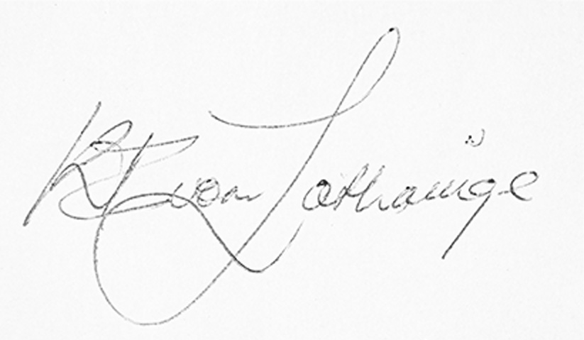

Karφlys Ignatius Von Lotharinge
His Imperial Majesty
Imperator Grandė Dominus
Emperor of Syno Aurelius
Grand Master of the Holy Order of Paladin Knights
Sovereign Monarch and Founder of Syno Aurelius

