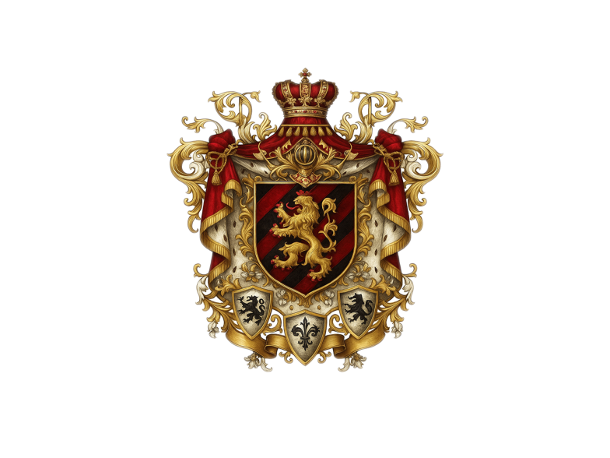
MEMORANDUM OF INCORPORATION
OF THE CONSTITUTIONAL MONARCHY OF SYNO AURELIUS

INSTRUMENT OF STATEHOOD

Issued in accordance with
the Royal Decree of His Imperial Majesty Karφlys Ignatius Von Lotharinge
Endorsed by His Excellency Dr. Monja Roindefo Zafitsimivalo, State President

- NAME AND STATUS
The name of the Nation shall be the Constitutional Monarchy of Syno Aurelius, hereinafter referred to as Syno Aurelius. Syno Aurelius is established as a Sovereign, Independent, and Autonomous Nation-State governed under the principles of a Constitutional Monarchy.

- FOUNDING AUTHORITY
Syno Aurelius is founded by His Imperial Majesty Karφlys Ignatius Von Lotharinge, in his capacity as the Sovereign Monarch and Imperator Grandė Dominus, under Divine and Historic Right, through the issuance of a Royal Decree and by virtue of legitimate sovereign capacity.

- PURPOSE OF INCORPORATION
The purpose of this Memorandum of Incorporation is to formally establish the legal identity, authority, and structural framework of Syno Aurelius as a Sovereign Nation, incorporating the following functions:

Legislative, Executive, Judicial, and Ceremonial Governance
Diplomatic and International Relations
Economic Development, Trade, and Monetary Sovereignty
National Security and Defence
Digital and Technological Innovation
Social Development and Public Service

- DOMICILE AND JURISDICTION
Syno Aurelius shall operate as a Digital Nation-State, with jurisdiction over its Virtual Private Network, Digital Platforms, and Physical Representational Offices globally, as established through bilateral treaties and state agreements.

- INSTRUMENTS OF STATEHOOD
The incorporation of Syno Aurelius shall be grounded upon the following primary Instruments of Statehood:

- Royal Decree of Establishment
- Founding Charter
- Proclamation of Sovereignty
- This Memorandum of Incorporation

- LEGAL FRAMEWORK
Syno Aurelius adheres to a hybrid legal framework incorporating:

International Law (as per United Nations Conventions and Treaties)
Civil Law and Customary Law
The Ontological and Rational Criteria of Statehood including:
Montevideo Convention on the Rights and Duties of States (1933)
Academic prescriptions on the ontology of sovereignty and governance

- COMPONENTS OF NATIONAL FORMATION
Syno Aurelius affirms compliance with both Primary Requirements and Secondary Attributes of Statehood:

- Primary Requirements (Montevideo Convention):
Permanent Population
Defined Territory (digital and physical)
Effective Government
Capacity for International Relations

- Secondary Attributes:
Financial Ability:
Central Bank;
National Currency
Primary: United States Dollar
Secondary: Syno Aurelius Dollar;
Exchange Rate Regime: Fixed to the USD on a 1:1 basis
Exchange Regime: Exchange, Trade, Dollarization, Conversion, Substitution

Economic Infrastructure:
State-Owned Enterprises;
Development Funds;
Trading Network;

Security Framework:
Military & National Defence
State Security & Intelligence
Civil Policing & Rule of Law

Emergency Preparedness:
Disaster Management;
Search & Rescue;
Coastguard;
Civil Response;

Institutional Services:
Legal & Oversight
Compliance & Governance

Information Technology
Digital Framework;
Database Management;
Enterprise System;
Digital Systems;
Communication Systems;

Human Resources:
Identification of Positions;
Recruitment & Appointment:
HR Management;
Government Appointments
Civic Employment Structure

- CONSTITUTIONAL GOVERNANCE
Syno Aurelius shall operate under a Constitutional Monarchy as follows:
- The Constitution of Syno Aurelius shall be the supreme legal authority
- Ceremonial authority with the Monarch;
- Executive authority with the State President;
- Legislative authority with Parliament;
- Judicial authority with the Judiciary;

- SOVEREIGN RIGHTS
Syno Aurelius reserves the sovereign right to:
- Form treaties and bilateral agreements
- Develop independent monetary and fiscal policy
- Maintain a military and police service
- Regulate immigration and citizenship
- Establish diplomatic missions globally

- DURATION AND CONTINUITY
This Memorandum of Incorporation shall have perpetual effect, forming part of the constitutional and legal archive of the State. It shall not be repealed except by a two-thirds majority of Parliament and assent of the Monarch.

SIGNED AND DECLARED
By Order of the State President:

His Excellency Dr. Monja Roindefo Zafitsimivalo
State President of Syno Aurelius

Countersigned by:



Karolys Ignatius fon Lotharinge
His Imperial Majesty
Imperator Grande Dominus
Emperor of Syno Aurelius
Grand Master of the Holy Order of Paladin Knights
Sovereign Monarch and Founder of Syno Aurelius


Issued on this 13th day of May, Year of 2019
